**SHRI SHAMBHUBHAI V. PATEL COLLEGE OF**

**COMPUTER SCIENCE & BUSINESS**

**MANAGEMENT**



Veer Narmad South Gujarat University

**Project Report**

**On**

**Online Food Ordering System**

**In partial fulfillment for the award of the degree**

**Of**

**BACHELOR OF COMPUTER APPLICATION**

**[B.C.A]**

**Year 2022-2023**

**SUBMITTED BY: GUIDED BY:**

**Godhani Geera A. Asst. Prof. Viral Patel**

**Shiroya Gopi B.**

**Rupareliya Ekta S.**

**BCA- 6th SEMESTER**

**INDEX**

|  |  |  |
| --- | --- | --- |
| **SR.NO** | **PARTICULAR** | **PAGE.**  **NO** |
| **1.** | **Introduction** |  |
|  | 1.1 Project Profile |  |
| **2.** | **System Environment** |  |
|  | 2.1 Hardware Used |  |
|  | 2.2 Software Used |  |
| **3.** | **Problem Specification** |  |
|  | 3.1 Introduction, Objective and Purpose |  |
|  | 3.2 System Model |  |
|  | 3.3 Feasibility study |  |
| **4.** | **Risk Identification and Management** |  |
|  | 4.1 Risk Monitoring |  |
| **5.** | **Technology Used for Development** |  |
| **6.** | **Planning** |  |
|  | 6.1 System Planning |  |
|  | 6.2 Time Line Chart |  |
| **7.** | **System Analysis** |  |
|  | 7.1 Database Design |  |
|  | 7.2 ER Diagram |  |
|  | 7.3 Data Flow Diagram |  |
|  | 7.4 Data Dictionary |  |
| **8.** | **Designing** |  |
|  | 8.1 User Interface |  |
| **9.** | **Testing** |  |
|  | 9.1 Software Testing |  |
|  | 9.2 Unit Testing |  |
|  | 9.3 System Testing |  |
| **10.** | **Reference** |  |

**Online Food Ordering**

1. **Introduction**

**1.1 Project Profile:**

|  |  |
| --- | --- |
| Project Name : | Online Food Ordering |
|  |  |
|  |  |
| Project Type : | Web Application |
| Duration : | 3 Months |
| Objective : | Providing best service to student, faculty and admin |
| Technology: | PHP, MySQL |
| Front End : | HTML, CSS, BOOTSTRAP |
| Back End : | PHP, MYSQL |
| Server : | Apache Server (Xampp) |
| Other Tools: | Javascript, Jquery |
| Internal Project Guide : | Prof. Viral Patel |
|  |  |
| Operating System: | Window 10 |
| Team Size: | 3 Members |
| Submitted To: | Shri Shambhubhai V. Patel College Of Computer Science& Business Management |
| Submitted By: | Ms. Godhani Geera  Ms. Siroya Gopi  Ms. Rupareliya Ekta |

The online food ordering system sets up a food menu online and customers can easily place the order as per they like. Also with a food menu, online customers can easily track the orders. The management maintains customer’s database, and improve food delivery service. The Restaurant management systems motivate us to develop the system.



There are various facilities provided so that the users of the system will get service effectively. Also, the system considers Restaurants as well as Mess facility to the customers. Again, the idea comes that mostly mess users are person who are shifted for various reason in new cities. So, they are interrelated. Increasing use of smart phones is also considered as a motivation, so that any users of this system get all service on single click.

Another motivation can be considered as the system will be designed to avoid users doing fatal errors, users can change their own can provide feedback and recommendations and can give ratings, it will give appropriate feedbacks to Restaurants / Mess service providers.

Due to lack of a full fledge application that can fulfil the customer requirements by providing him food from restaurants as well as from mess service, there is a need for the system. This proposed system will be used by the people who keep shifting from cities to cite. As well as, it will be useful for the students studying in different cities.

proﬁle, users can track their food items through GPS, users

roﬁle, users can track their food items through GPS, userscan provide feedback and recommendations and can give

The proposed system will provide the flexibility to the Customers/Users to order from either Restaurants or Mess. It will also provide Recommendations to the customers from the restaurants/mess owners uploaded on a daily basis. In the proposed system, there will be no limitation on the amount of order the customer wants. Also, same application can be used as a Start up Business for the developers.

1. **System**

**Environment**

**2.1 Hardware Used**

* **Client Side:**

|  |  |
| --- | --- |
| Processor : | Intel core i5 Processor |
| Hard Drive : | 1TB |
| RAM: | 8 GB |
|  |  |

* **Server Side:**

|  |  |
| --- | --- |
| Processor : | Intel core i5 Processor |
| Hard Drive : | 1TB |
| RAM: | 8 GB |

**2.2 Software Used**

* **Client Side:**

|  |  |
| --- | --- |
| Operating System: | Windows 10 |
| Internet: | Required |
| Browser: | Chrome (Recommended)you can use any lestest browser |
|  |  |

* **Server Side:**

|  |  |
| --- | --- |
| Operating System: | Windows 10 |
| Front End: | HTML |
| Back End: | MY SQL |
| Framework: | Core PHP |

1. **Problem**

**Specification**



**3.1 Introduction, Objective and Purpose**

To overcome the limitations of above system, an Online Food Ordering System based on Internet of Things is proposed. It is a wireless food ordering system using android devices. Android devices have gained immense popularity and have revolutionized the use of mobile technology in the automation of routine task in wireless environment. Android is a Linux based operating system for mobile devices such as smart-phones and tablets. To develop a reliable, convenient and accurate Food Ordering System is considered as a general

Objective of the study. To develop a system that will surely objective. One of the Objectives is to design a system that is able to accommodate huge amount

satisﬁed the customer service will be considered as an

Of order sat a time and automatically compute the bill. To evaluate its performance and acceptability in terms of security, user-friendliness, accuracy and reliability is an important objective. To improve the communication between the client and customers is one of the objectives. The figure.1 represents the simple system architecture of the proposed system: -

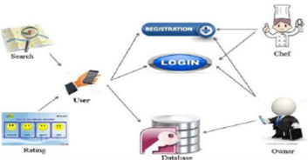

The architectural design consists of 3 main users: -Service Consumer, Owner of Mess/Restaurant, and Employee of for hygienic and quality food, so he

mess. When a person shifted to new city he has to ﬁnd source

She will search and select restaurant or home-based food service based on his category and as well as service that is veg or non-veg.

Here the main function is in what pattern user will search the service so for that purpose a part of Geo-Hashing Algorithm is used, and GPS system should be on. Person can have the facility to search service by location that is home location of the person is detected with GPS and according to selected option location of nearby service get searched. Another way for searching is by cost. Here user must give input in terms of rupees that in what range he/she need service per plate if there are any service provider within that area than the list will display.

User can also search by rating. The service that has rating is checked by user given rating and if matched it will give the list of service. Search can be done by accepting distance from user in which user need to search and displaying service provider within that distance. User can communicate to service provider with the help of message box and get provider has facility to add or reject request from person who want to join the service.

**Objective:**

The objective of this project is to study how the online food ordering website work sands the process of the system followed by the users.

* **Admin :**
* Manage Users
* Manage Admin Profile
* Manage Account
* Manage Customer
* Manage Customer Feedback
* **Customer :**
* View order details
* Orders Placed
* Place order any time
* Pay Online Bill

Online Food Order System has been developed which is originally designed for small scale business. But this system is applicable in any restaurant. The main advantage of this online system is that it greatly simplifies the food ordering process for both of the customer and the restaurant. The anticipated benefits of the project are:

1. This will speed up the ordering process.

2. The system will help to reduce lab our cost involved.

3. The system will be less probable to make mistake, since it’s a machine

4. The top benefit of online ordering was a savings in lab our, since employees are not tied up on the phone or at the counter.

5. To develop an application which gives provision to the restaurant owner’s to flourish their business by uploading menus at no cost and will invariably lead to

Higher customer retention and acquisition rates.

6. To ensure customer satisfaction.

7. To increase efficiency and improve services provided to the customers through better application of technology.

8. It is designed to increase efficiency, save money and time.

9. It shows the correct menu and enables the customers to order items that are

Available.

10. To avoid long queues at the counter.

11. To accommodate huge amount of orders at a time

12. To improve the communication between the client and the server

notiﬁcation from provider end if any. On the other end

**3.2 System Model:**

**3.3 Feasibility Study:**

A feasibility study is a test of a system proposal. According to its workability,

Impacts on the organization, ability to meet user needs and effective use of the

Resources its main task done during feasibility study is:

**Evaluation of existing system and procedure:**

For placing any orders customers have to visit hotels or restaurants to know about Food items and then place order and pay, for that process time and manual work is required. While placing an order over the phone, customer lacks the physical copy of the menu item, lack of visual confirmation that the order was placed correctly.

**Economy feasibility:**

We have estimated that the cost for the development of this website will be minimum which will benefits the developers.

**Technical feasibility:**

Technical feasibility this project will be focused on gaining an understanding of

The present technical resources of the organization and their applicability to the

Expected needs of the proposed system. It is an evaluation of the hardware and software and how it meets the needs of the proposed system. The systems project is considered technically feasible if the internal technical capability is sufficient to support the project requirements.

.

**Operational feasibility:**

:

Operational feasibility is the measure of how well the project will support the

Customer and the service provider during the operational phase.

1. **. Risk Identification**

**And Management**

**What is Risk?**



The objectives of project risk management are to increase the likelihood and impact of positive events and decease the likelihood and impact of negative events.

**4.1 Risk Monitoring:**

Maintaining ongoing awareness of an organization's risk environment, risk management program, and associated activities to support risk decisions.

Another simple risk monitoring and control example would be if there has been some unexpected weather forecast. Companies always monitor powerful external forces like these, and a slate of bad weather may require them to put in some additional controls around work and production rates, as well as workplace safety.

These tools can include key performance indicators (KPIs), dashboards, checklists, and monitoring plans. Monitoring tools are used to gather qualitative and quantitative data. The choice of tool will depend on the type of information needed, the resources available, and the specific monitoring goals and objective

**Timing:**



**Risk Management**

* When the project start
* Monthly Meeting with all the departments

**Development**

* Weekly check the schedule on building APP

**Marketing**

* Monthly do the APP Marketing Research
* Modify the marketing strategy

**Financial**

* Review all the contract documents

**Human Resource**

* Monthly tracking the effectively of the staffs

**TOP 5 Risks**

* Delivery Delay
* Outsource Monitoring
* Solve customer complaints
* Compete with similar service
* Hire new staff

**Risk 1**

* Delivery Delay

**Cause / Effect**

* Traffic Problem
* Making the customers feel angry

**Strategy**

* Avoid

**Response**

* Use GPS to take a better route

**Risk 2**

* Outsource Monitoring

**Cause / Effect**

* Lack of monitoring of outsourcing
* Loss of business

**Strategy**

* Mitigate

**Response**

* Hire a monitoring supervisor to control the outsource companies

**Risk 3**

* Solve customer complaints

**Cause / Effect**

* Slow process of customer’s feedback
* Bad reputation of the app

**Strategy**

* Mitigate

**Response**

* Check all the bad reviews and create action plan to solve the complaints

**Risk 4**

* Compete with similar service

**Cause / Effect**

* Lack of research of competitors
* Lack of loyal customers

**Strategy**

* Mitigate

**Response**

* Keep a regular check and take actions on the price and quality of competitor

**Risk 5**

* Hire new staff

**Cause / Effect**

* Assign work to new staff
* Cost more on Training

**Strategy**

* Mitigate

**Response**

* Pay good salaries and better benefits to retain staff

**5. Technology Used For Development**

**HTML**

**HTML** stands for Hyper Text Markup Language. It is used to design web pages using a markup language. HTML is the combination of Hypertext and Markup language. Hypertext defines the link between web pages. A markup language is used to define the text document within the tag which defines the structure of web pages. This language is used to annotate (make notes for the computer) text so that a machine can understand it and manipulate text accordingly. Most markup languages (e.g. HTML) are human-readable. The language uses tags to define what manipulation has to be done on the text.

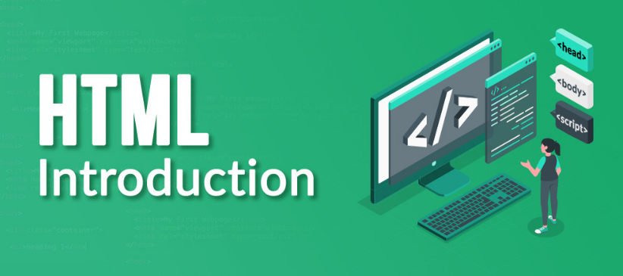

* [<style>](https://www.geeksforgeeks.org/html-style-tag/)-This html tag allows us to insert styling into our web pages and make them appealing to look at with the help of CSS.
* [<title>](https://www.geeksforgeeks.org/html-title-tag/)-The title is what is displayed on the top of your browser when you visit a website and contains title of the webpage that you are viewing.
* [<base>](https://www.geeksforgeeks.org/html-base-tag/)-It specifies the base URL for all relative URL’s in a document.
* [<noscript>](https://www.geeksforgeeks.org/html-noscript-tag/)– Defines a section of HTML that is inserted when the scripting has been turned off in the users browser.
* [<script>](https://www.geeksforgeeks.org/html-script-tag/)-This tag is used to add functionality in the website with the help of JavaScript.
* [<meta>](https://www.geeksforgeeks.org/html-meta-tag/#:~:text=The%20tag%20in%20HTML,keywords%2C%20document%20author%2C%20etc.)-This tag encloses the meta data of the website that must be loaded every time the website is visited. For eg:- the metadata charset allows you to use the standard UTF-8 encoding in your website. This in turn allows the users to view your webpage in the language of their choice. It is a self closing tag.
* [<link>](https://www.geeksforgeeks.org/html-link-tag/)– The ‘link’ tag is used to tie together HTML, CSS and JavaScript. It is self closing.
* [**<body>**](https://www.geeksforgeeks.org/html-body-tag/#:~:text=The%20tag%20in%20HTML,well%20as%20an%20ending%20tag.)**:** The body tag is used to enclose all the visible content of a webpage. In other words, the body content is what the browser will show on the front-end.

An HTML document can be created using any text editor. Save the text file using **.html** or **.html**. Once saved as an HTML document, the file can be opened as a webpage in the browser.

**Why we use HTML?**

HTML—“HyperText Markup Language”—is the language used to tell your web browser what each part of a website is. So, using HTML, you can define headers, paragraphs, links, images, and more, so your browser knows how to structure the web page you're looking at.

**CSS**

CSS is the language we use to style an HTML document.

* CSS stands for Cascading Style Sheets.
* CSS describes how HTML elements are to be displayed on screen, paper, or in other media.
* CSS saves a lot of work. It can control the layout of multiple web pages all at once.
* External style sheets are stored in CSS files and of that file is css.

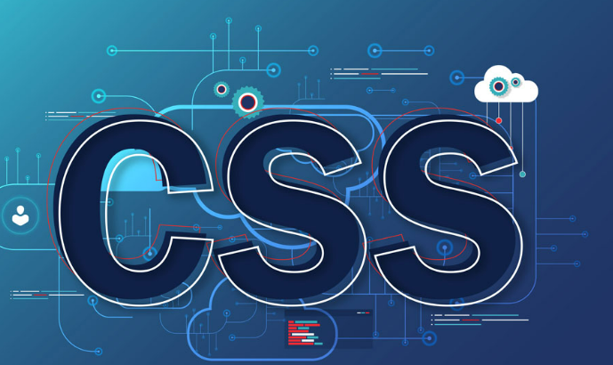

**Why We Use CSS?**

CSS (Cascading Style Sheets) is used to style and layout web pages — for example, to alter the font, color, size, and spacing of your content, split it into multiple columns, or add animations and other decorative features.

**JQUERY**

JQuery is a JavaScript framework; which purpose is to make it much easier to use JavaScript on your website. JQuery is a small, light-weight and fast JavaScript library. It is cross-platform and supports different types of browsers. It is also referred as write less do more because it takes a lot of common tasks that requires many lines of JavaScript code to accomplish, and binds them into methods that can be called with a single line of code whenever needed. It is also very useful to simplify a lot of the complicated things from JavaScript, like AJAX calls and DOM manipulation.

**Why we use JOUERY?**

The purpose of jQuery is to make it much easier to use JavaScript on your website. jQuery takes a lot of common tasks that require many lines of JavaScript code to accomplish, and wraps them into methods that you can call with a single line of code.



* JQuery is a small, fast and lightweight JavaScript library.
* JQuery is platform-independent.
* JQuery means "write less do more".
* JQuery simplifies AJAX call and DOM manipulation.

**JAVASCRIPT**

JavaScript is a scripting or a programming language, allowing developers to perform complex features on web pages. Initially, this language was created for making web pages alive. In JavaScript, the programs are called scripts. One can write them in the HTML of a web page, and then it will automatically run once the page loads. At this point, JavaScript is completely different from another language, called Java.

**Why we use JAVASCRIPT?**

JavaScript is a scripting language used to develop web pages. Developed in Netscape, JS allows developers to create a dynamic and interactive web page to interact with visitors and execute complex actions. It also enables users to load content into a document without reloading the entire page.

Initially, when JavaScript was created, it was called “Live Script”. Java was extremely popular in that period, and then it was decided to call it JavaScript to position it relative to Java. But, over the years, JavaScript has transformed into a completely independent language, with its specification, known as ECMA script, having no relation to Java. Modern JavaScript can both work in the browser and on the server. Basically, it can run on any device that has

a specific program known as the JavaScript engine.

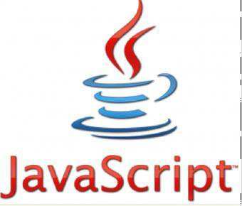

* All popular web browsers support JavaScript as they provide built-in execution environments.
* JavaScript follows the syntax and structure of the C programming language.
* JavaScript is a weekly typed language, where certain types are implicitly cast.
* JavaScript is an object-oriented programming language that uses prototypes rather than using classes for inheritance.
* It is a light-weighted and interpreted language.
* It is a case-sensitive language.

# BOOTSTRAP

Bootstrap is a free and open-source web development framework. It’s designed to ease the web development process of responsive, mobile-first websites by providing a collection of syntax for template designs.

In other words, Bootstrap helps web developers build website faster as they don’t need to worry about basic commands and functions. It consists of HTML, CSS, and JS-based scripts for various web design-related functions and components.

This article will cover the benefits of using Bootstrap and explain the different file types it uses. By the end, you will know whether Bootstrap can benefit your workflow.

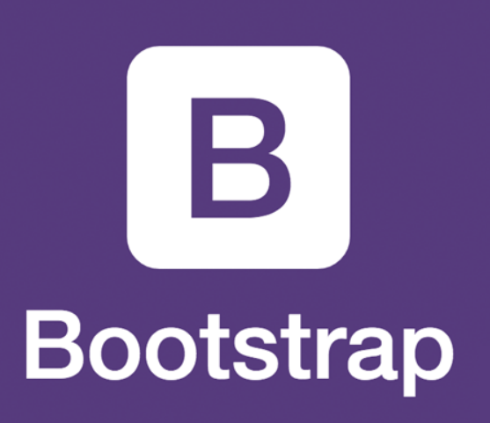

**Why we use BOOTSTRAP?**

What is Bootstrap used for? Bootstrap makes responsive web design a reality. It makes it possible for a web page or app to detect the visitor's screen size and orientation and automatically adapt the display accordingly.

**PHP**

The term PHP is an acronym for PHP: Hypertext Preprocessor. PHP is a server side scripting language designed specifically for web development. It is open-source, which means it is free to download and use. It is very simple to learn and use. The files have the extension “.php”.

PHP was created by Rasmus Leadoff in 1994, but it was appeared in the market under 1995. Some important points need to be noticed about PHP are as followed:

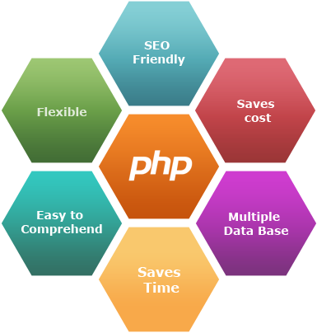

* PHP stands for Hypertext Preprocessor.
* PHP is an interpreted language, i.e., there is no need for compilation.
* PHP is faster than other scripting languages, for example, ASP and JSP.
* PHP is a server-side scripting language, which is used to manage the dynamic content of the website.
* PHP can be embedded into HTML.
* PHP is an object-oriented language.
* PHP is an open-source scripting language.
* PHP is a secure language to develop the website.
* PHP is available for WINDOWS, MAC, and LINUX & UNIX operating system.
* PHP supports all the leading databases such as MySQL, SQLite, ODBC, etc.

**Why we use PHP?**

PHP allows web developers to create dynamic content and interact with databases. PHP is known for its simplicity, speed, and flexibility — features that have made it a cornerstone in the web development world.

**MYSQL**

MySQL is one of the most recognizable technologies in the modern big data ecosystem. Often called the most popular database and currently enjoying widespread, effective use regardless of industry, it’s clear that anyone involved with enterprise data or general IT should at least aim for a basic familiarity of MySQL.

With MySQL, even those new to relational systems can immediately build fast, powerful, and secure data storage systems. MySQL’s programmatic syntax and interfaces are also perfect gateways into the wide world of other popular query languages and structured data stores**.**

A database is a structured collection of data. It may be anything from a simple shopping list to a picture gallery or a place to hold the vast amounts of information in a corporate network.

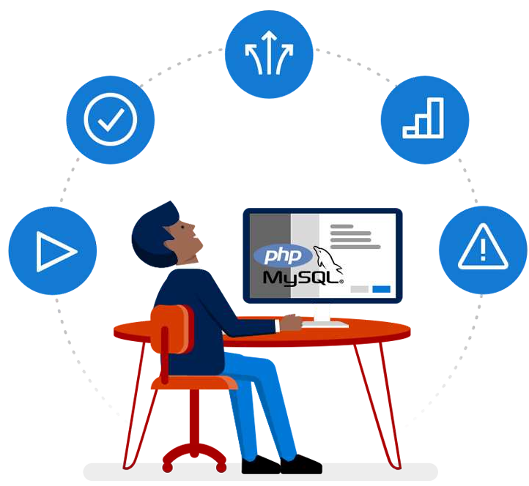

In particular, a relational database is a digital store collecting data and organizing it according to the relational model. In this model, tables consist of rows and columns, and relationships between data elements all follow a strict logical structure. An RDBMS is simply the set of software tools used to actually implement, manage, and query such a database.

**Why we use MYSQL?**

MySQLoffers encryption using the Secure Sockets Layer (SSL) protocol, data masking, authentication plugins, and other layers of security to protect data integrity. The MySQL Enterprise package also includes firewall protection against cyberattacks.

**VISUAL STUDIO CODE**

Visual Studio is an **Integrated Development Environment(IDE)** developed by Microsoft to develop GUI(Graphical User Interface), console, Web applications, web apps, mobile apps, cloud, and web services, etc. With the help of this IDE, you can create managed code as well as native code. It uses the various platforms of Microsoft software development software like Windows store, Microsoft Silverlight, and Windows API, etc. It is not a language-specific IDE as you can use this to write code in C#, C++, VB(Visual Basic), Python, JavaScript, and many more languages. It provides support for 36 different programming languages. It is available for Windows as well as for macOS. **Evolution of Visual Studio:** The first version of



VS(Visual Studio) was released in 1997, named as Visual Studio 97 having version number 5.0. The latest version of Visual Studio is 15.0 which was released on March 7, 2017. It is also termed as Visual Studio 2017. The supported *.Net Framework Versions* in latest Visual Studio is 3.5 to 4.7. Java was supported in old versions of Visual Studio but in the latest version doesn’t provide any support for Java language.

**XAMPP SERVER**

XAMPP is an acronym that stands for Cross-Platform, Apache, MySQL, PHP, and Perl, with the Ps standing for PHP and Perl, respectively. It’s an open-source web-solutions kit that provides Apache delivery for a variety of servers and command-line executables, as well as Apache api, MariaDB, PHP, and Perl modules.



Until releasing a website or client to the main cloud, XAMPP allows a local host or server to validate it on computers and laptops. It is a framework that provides a suitable environment for testing and verifying the functionality of projects based on Apache, Perl, MySQL, and PHP using the host’s framework. Perl is a web creation programming language, PHP is a backend scripting language, and MariaDB is MySQL’s most widely used database. The following is a brief overview of these elements.

XAMPP stands for eXtremely Accelerated Multi-Processing Packet Processing (A) Apache server, (M) MariaDB, (P) PHP, and (P) Perl. X stands for Cross-platform, (A) Apache server, (M) MariaDB, (P) PHP, and (P) Perl. The term “cross-platform” typically refers to the ability to run on any device, regardless of operating system.

**6. Planning**

**6.1 System Planning:**

|  |  |
| --- | --- |
|  | |
|  | 1. **Get the right POS system**   Consider a system that has delivery options, online Ordering and the ability to capture customer data. |
|  | 1. **Tweak your kitchen line**   The kitchen line will need to be capable of dealing with high order volumes and prioritizing them. |
|  | 1. **Choose your ordering service**   You could opt to take, process and deliver the food yourself, but there’s a reason the likes of UberEATS exist. |
|  | 1. **Decide food transportation**   You’ll need to tackle thorny issues like whether or not employees can use their own cars or company cars. |
|  | 1. **Consider branded packaging**   Deliverer may brand deliveries with their livery, but you might have the opportunity to use your own. |
|  | 1. **Create a separate delivery menu**   Don’t feel like you have to offer the exact same in-house menu for delivery customers. |

We’re not about to suggest that setting up a food delivery service from scratch is easy - it requires plenty of pre-planning.

This is why jumping in head-first isn’t a good idea.

You need to do your homework and prepare. Therefore, before you do anything, consider these six vital planning steps.

**1. Get the right POS system**

The point of sale (POS) system will sit at the heart of your restaurant operation, but it’ll need to handle delivery too, if that’s your plan.

The good news is that many modern POS systems offer this functionality, and it might just need turning on. Speak to your vendor first, and if they can’t provide it, consider a system that has delivery options, online ordering and the ability to capture customer data.

**2. Tweak your kitchen line**

Very few traditional restaurant kitchen lines are ready to take on the intricacies of a delivery service, so make sure yours is, before you start taking orders.

The POS should help (see above), but the kitchen line will need to be capable of dealing with high order volumes and prioritising them effectively, while still providing the in-house service.

Foodservice training might be required, and it pays to listen to staff that have held previous roles in order delivery for their input.

**3. Choose your online ordering service**

You could opt to take process and deliver the food yourself, but there’s a reason the likes of UberEATS and Deliveroo exist.

They’ll take a portion of each sale, but will in return provide an invaluable service.

**4. Think carefully about food transportation**

Even if you use one of the services above, you might have the option to deliver yourself once the ordering is taken care of.

Think carefully about this. In doing so, you’ll need to tackle thorny issues like whether or not employees can use their own cars or company cars. You’ll also probably need to significantly change their terms of employment to take into account new driving duties.

If it feels safer and more cost-effective to use one of the aforementioned online ordering services’ delivery options - do so.

**5. Consider branded packaging**

Once again, if you use a service like Deliveroo, they may brand deliveries with their company livery, but you might have the opportunity to use your own.

If that’s the case, this can be a great way to stick in the minds of your delivery customers. Think about it; what’s the first thing they might see when heading into the kitchen the morning after they’ve consumed your takeaway?

**6. Create a separate delivery menu**

Don’t feel like you have to offer the exact same in-house menu for delivery customers. In fact, there may be certain dishes which really *don’t* suit delivery!

Instead, work on a separate menu for delivery. Optimise it for fast prep and freshness while in transportation. Consider what the competition is doing, too; they may have already nailed the requirements in this area.

It’s also important to calculate the optimal shelf life of your food. This will help you estimate delivery windows and enable the team to prioritise delivery items efficiently for the best takeaway experience.

**6.2 Time Line Chart:**

Time-scarcity is driving consumers leading on-the-go, complex lifestyles, to look for time-saving, convenient meal solutions, enhancing the appeal of online food delivery services. Growing demand for a greater variety of cuisine types and dish options, especially among young urban consumers, will continue to fuel growth and diversification in the market.

Listed below are the major milestones in the journey of the Online Food Delivery theme, as identified by Global Data.

|  |  |  |  |  |  |  |  |  |  |  |  |  |
| --- | --- | --- | --- | --- | --- | --- | --- | --- | --- | --- | --- | --- |
|  |  | | | | | | | | | | | |
|  | Week 1 | | | Week 2 | | | Week 3 | | | Week 4 | | |
|  |  | | |  |  |  |  |  |  |  |  |  |
|  |  |  |  |  | | |  |  |  |  |  |  |
|  |  |  |  |  |  |  |  |  |  |  |  |  |

|  |  |  |  |  |  |  |  |  |  |  |  |  |
| --- | --- | --- | --- | --- | --- | --- | --- | --- | --- | --- | --- | --- |
|  | | | | | | | | | | | | |
|  |  |  |  |  |  |  |  |  |  |  |  |  |
|  |  |  |  |  |  |  |  |  |  | |  |  |
|  |  |  |  |  |  |  |  |  |  |  |  | |

|  |  |  |  |  |  |  |  |  |  |  |  |  |
| --- | --- | --- | --- | --- | --- | --- | --- | --- | --- | --- | --- | --- |
|  |  | | | | | | | | | | | |
|  | Week 5 | | | Week 6 | | | Week 7 | | | Week 8 | | |
|  |  | | |  |  |  |  |  |  |  |  |  |
|  |  |  |  |  | | | | | |  |  |  |
|  |  |  |  |  |  |  |  |  |  |  | | |

|  |  |  |  |  |  |  |  |  |  |  |  |  |
| --- | --- | --- | --- | --- | --- | --- | --- | --- | --- | --- | --- | --- |
|  |  | | | | | | | | | | | |
|  | Week 9 | | | Week 10 | | | Week 11 | | | Week 12 | | |
|  |  | | |  |  |  |  |  |  |  |  |  |
|  |  |  |  |  | | |  |  |  |  |  |  |
|  |  |  |  |  |  |  |  | | |  |  |  |

|  |  |  |  |  |  |  |  |  |  |  |  |  |
| --- | --- | --- | --- | --- | --- | --- | --- | --- | --- | --- | --- | --- |
|  | | | | | | | | | | | | |
|  |  |  |  |  |  |  |  |  |  |  | |  |
|  |  |  |  |  |  |  |  |  |  |  |  |  |

**7. System Analysis**

The System Analysis is detailed appraisal of the existing system. This appraisal includes how the system works and what it does. It also includes finding out in more detail- what are the problems with the system and what user requires from the new system or any new change in system. The output of this phase results in the detail model of the system. The model describes the system functions and data and system information flow. The phase also contains the detail set of user requirements and these requirements are used to set objectives for the new system.

**7.1 Database Design:**

|  |  |  |  |
| --- | --- | --- | --- |
| **Registration** | | | |
| No. | Field Name | Data type | Constraint |
| 1 | Id | INT | Primary key |
| 2 | user id | VARCHAR |  |
| 3 | Password | VARCHAR |  |
| 4 | Email | VARCHAR |  |

|  |  |  |  |
| --- | --- | --- | --- |
| **Menu** | | | |
| No. | Field Name | Data type | Constraint |
| 1 | p_id | INT | Primary key |
| 2 | Title | VARCHAR |  |
| 3 | Price | BIGINT |  |
| 4 | Image | TEXT |  |

|  |  |  |  |
| --- | --- | --- | --- |
| **Add cart** | | | |
| No. | Field Name | Data type | Constraint |
| 1 | Id | INT | Primary key |
| 2 | p_id | INT |  |
| 3 | Title | VARCHAR |  |
| 4 | user id | VARCHAR |  |
| 5 | Price | BIGINT |  |
| 6 | Qty | BIGINT |  |
| 7 | Total | BIGINT |  |

|  |  |  |  |
| --- | --- | --- | --- |
| **checkout** | | | |
| No. | Field Name | Data type | Constraint |
| 1 | id | INT | Primary key |
| 2 | user id | VARCHAR |  |
| 3 | title | VARCHAR |  |
| 4 | qty | BIGINT |  |
| 5 | total | BIGINT |  |
| 6 | name | VARCHAR |  |
| 7 | mobile | BIGINT |  |
| 8 | email | VARCHAR |  |
| 9 | location | TEXT |  |

|  |  |  |  |
| --- | --- | --- | --- |
| **Review** | | | |
| No. | Field Name | Data type | Constraint |
| 1 | id | INT | Primary key |
| 2 | name | VARCHAR |  |
| 3 | review | VARCHAR |  |
| 4 | description | TEXT |  |

|  |  |  |  |
| --- | --- | --- | --- |
| **Contact** | | | |
| No. | Field Name | Data type | Constraint |
| 1 | id | INT | Primary key |
| 2 | name | VARCHAR |  |
| 3 | email | VARCHAR |  |
| 4 | msg | TEXT |  |

|  |  |  |  |
| --- | --- | --- | --- |
| **Admin** | | | |
| No. | Field Name | Data type | Constraint |
| 1 | admin id | INT | Primary key |
| 2 | password | VARCHAR |  |

**7.2 ER Diagram:**

**7.3 Data Flow Diagram:**

* Also Know as DFD, Data flow diagrams are used to graphically represent the flow of data in a business information system. DFD describes the processes that are involved in a system to transfer data from the input to the file storage and reports generation.
* Data flow diagrams can be divided into logical and physical. The logical data flow diagram describes flow of data through a system to perform certain functionality of a business. The physical data flow diagram describes the implementation of the logical data flow.

**Symbols used in DFD’s**

* External Entity
* Process
* Data Store
* Data Flow

1. **External Entity:**

* An Outside system that sends or receives data, communicating with the system being diagrammed.
* They are the sources and destinations of information entering or leaving the system. They might be an outside organization or person, a computer system or a business system.
* They are also known as terminators, sources and sinks or actors. They are typically drawn on the edges of the diagram.

1. **Process:**

* Any process that changes the data, producing an output. It might perform computations. Or sort data based on logic. Or direct the flow based on business rules. A short label is used to describe the process, such as “Submit Payment.”

1. **Data Store:**

* Files or repositories that hold information for later use. Such as a database table or a membership form. Each data store receives a simple label, such as “Orders.”

1. **Data Flow:**

* The route that data takes between the external entities, processes and data stores. It portrays the interface between the other components and is shown arrows, typically labeled with a short data name, like “Billing details.”

**Context Level DFD**

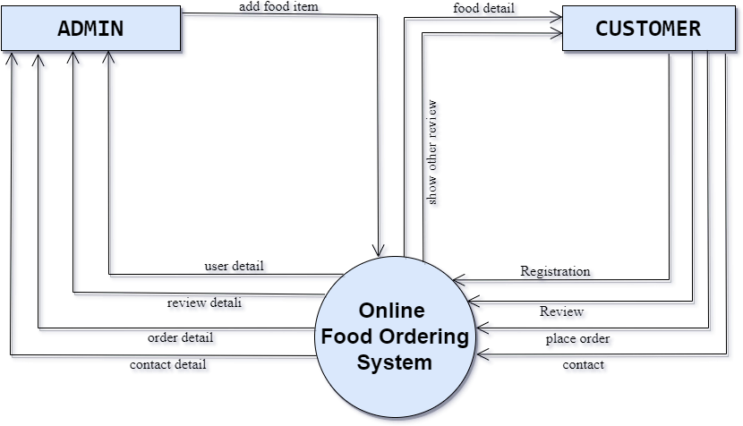**[Context Level DFD]**

**1st level DFD**

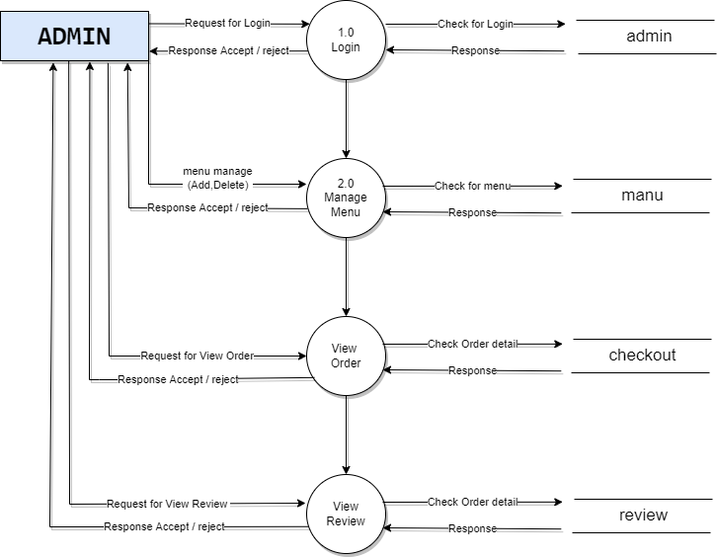

**[1st level DFD Admin]**

**System Flow Diagram**

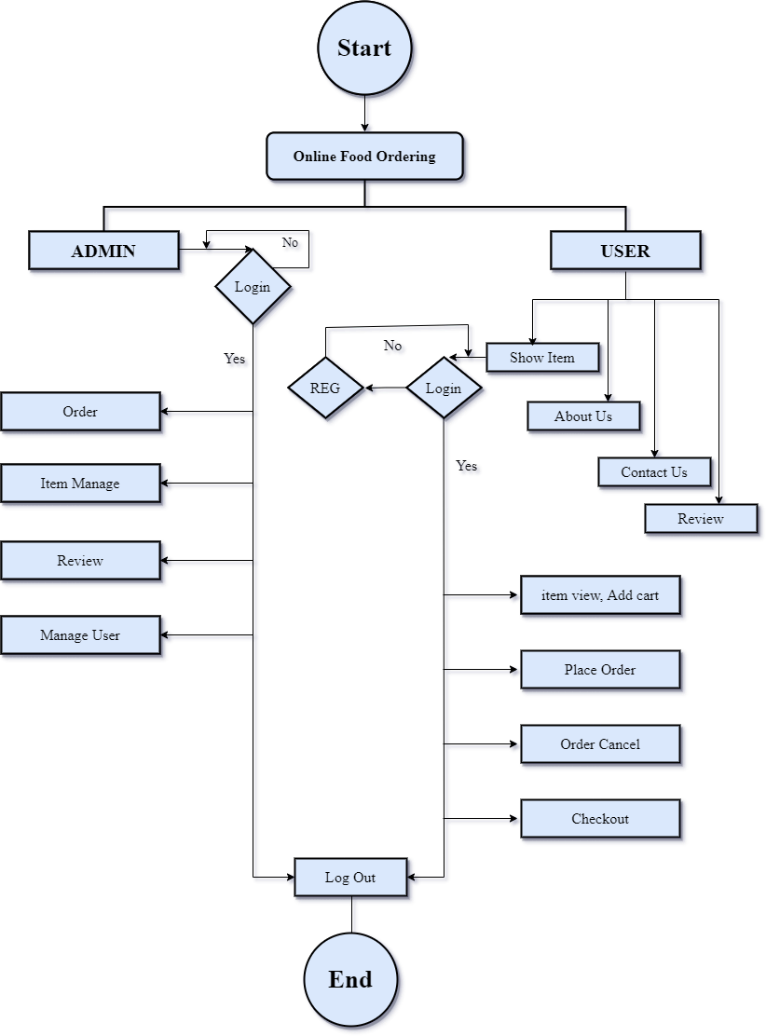

**[System Flow Diagram]**

**Process Specification**

1. **Customers Login**



1. **Food List**



1. **Customer Profile**

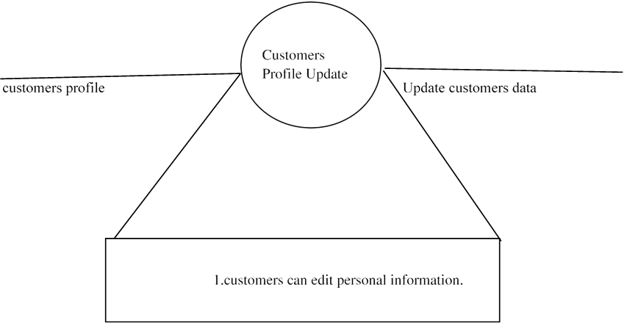

1. **Receive Order From Customer**

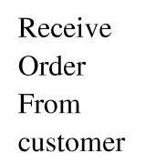

1. **Admin Login**



1. **Admin Password**



1. **Manage Customer**



**7.4 Data Dictionary:**

**8. Designing**

**8.1 User Interface:**

The user interface (UI) is the point of human-computer interaction and communication in a device. This can include display screens, keyboards, a mouse and the appearance of a desktop. It is also the way through which a user interacts with an application or a website.

The growing dependence of many businesses on web applications and mobile applications has led many companies to place increased priority on UI in an effort to improve the user's overall experience.

* **Login Now Page**

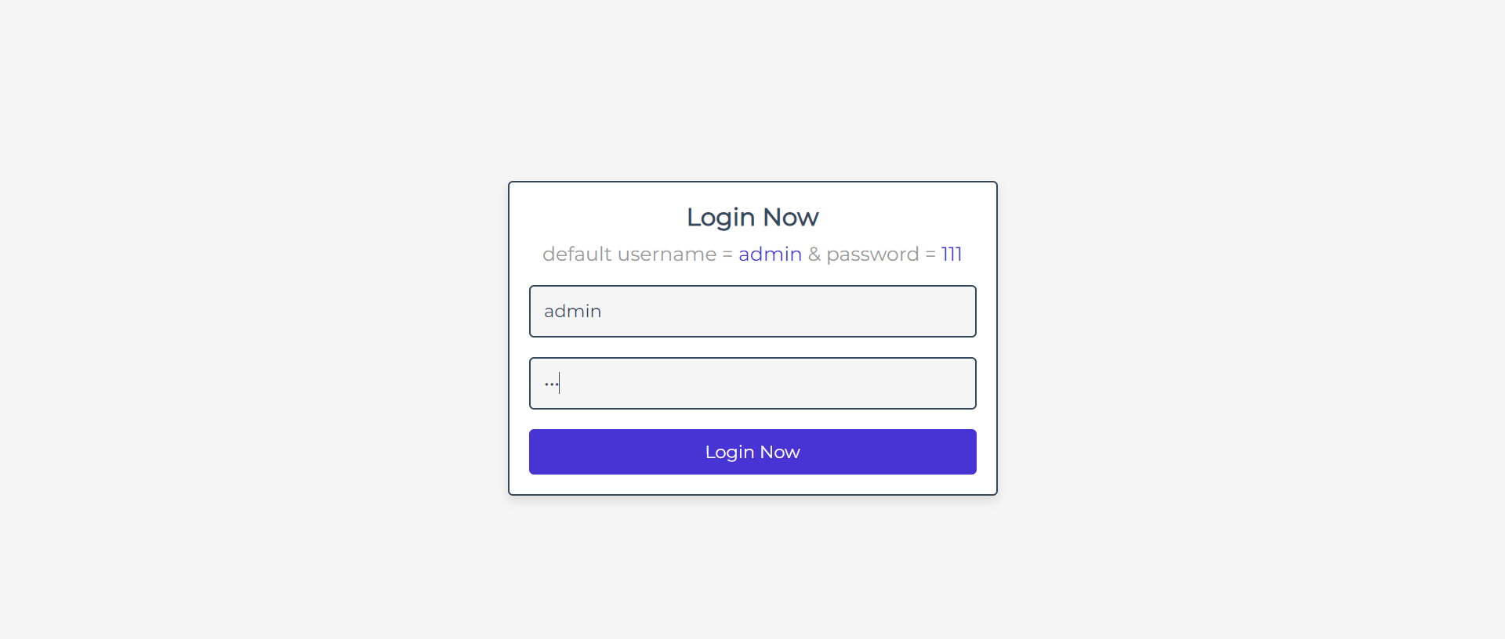

**Home Page**

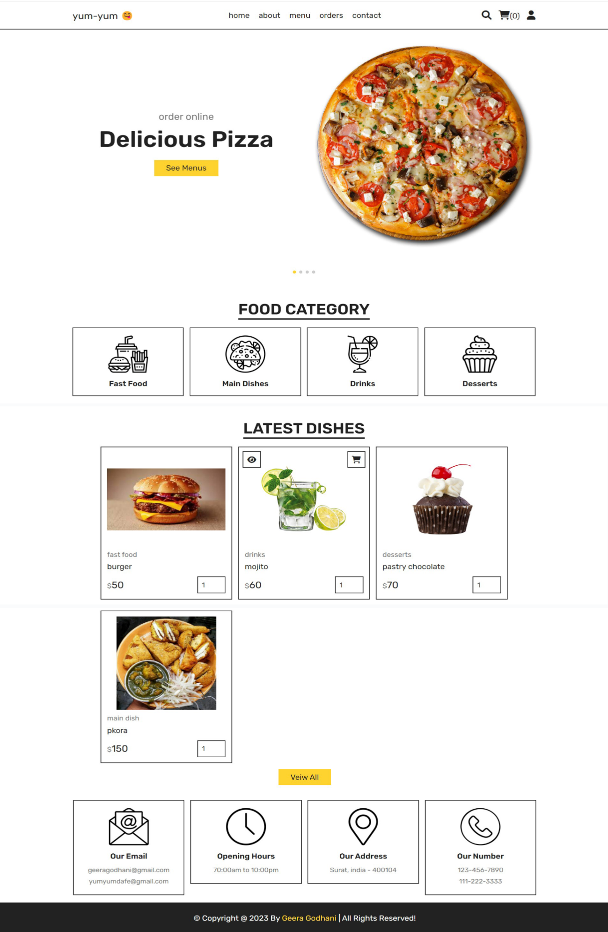

* **About Us Page**

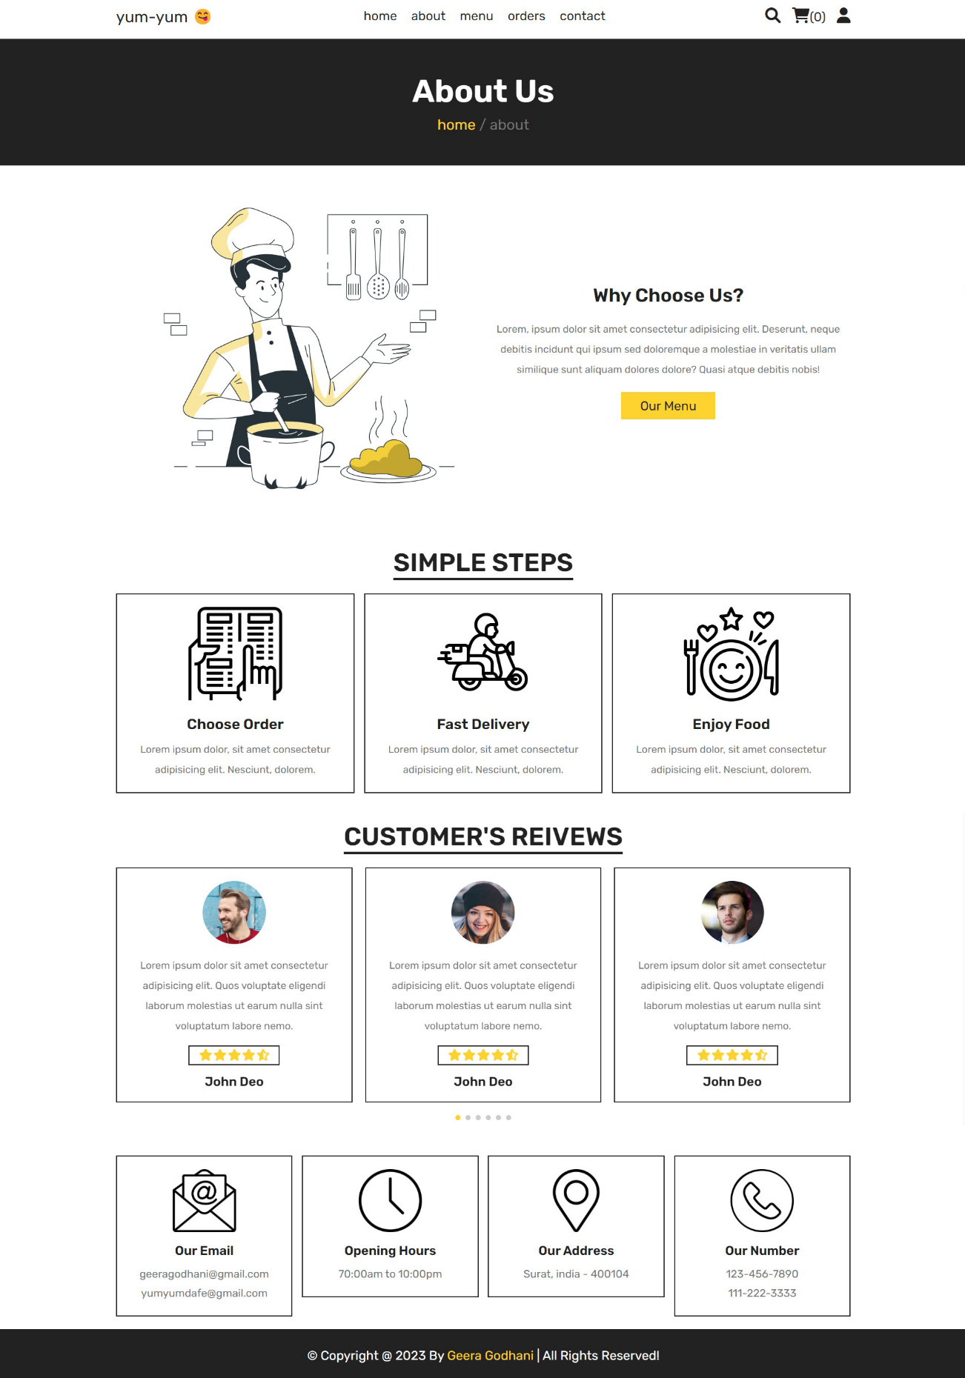

* **Our Menu Page**

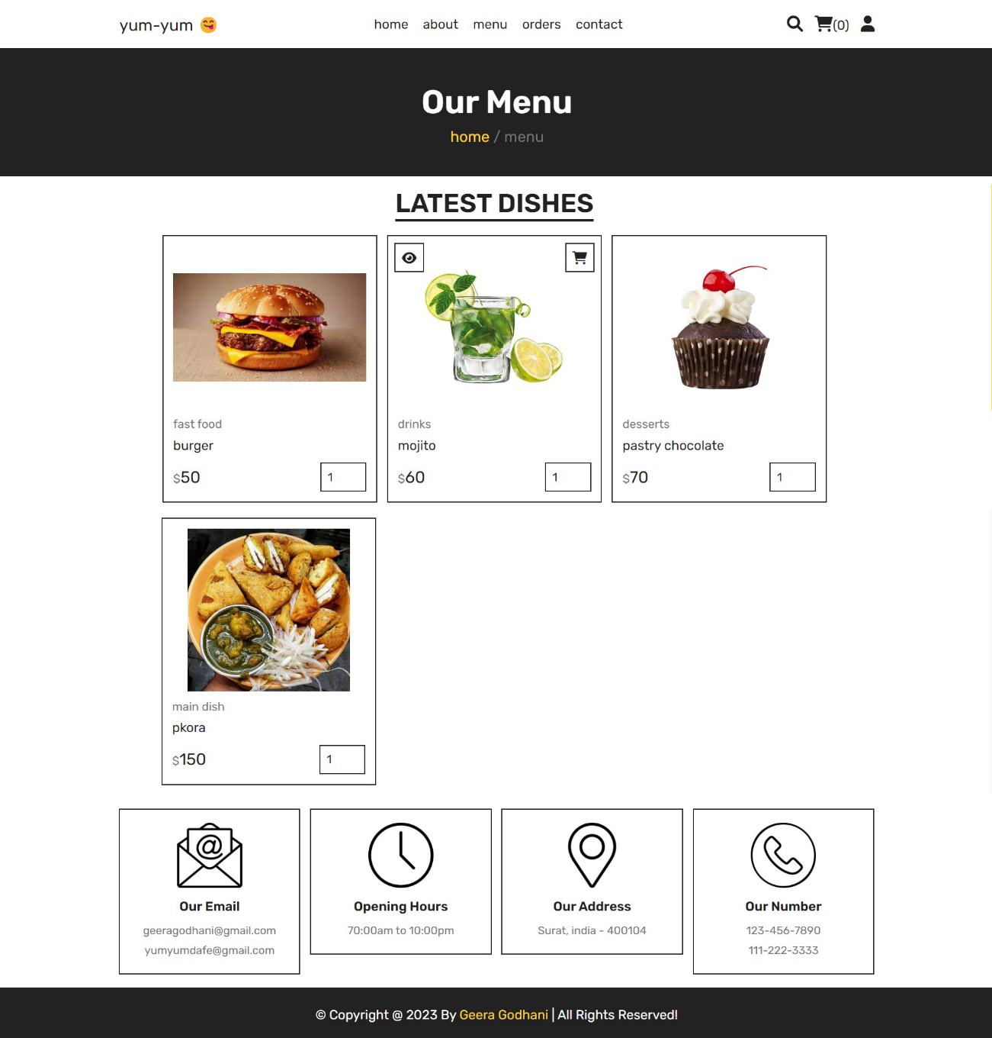

* **Order Page**

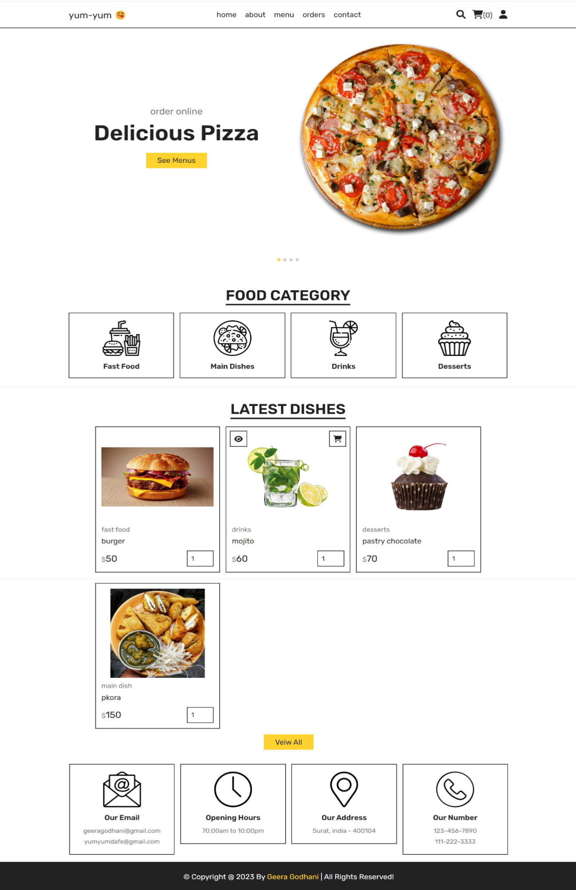

* **Contact Us Page**

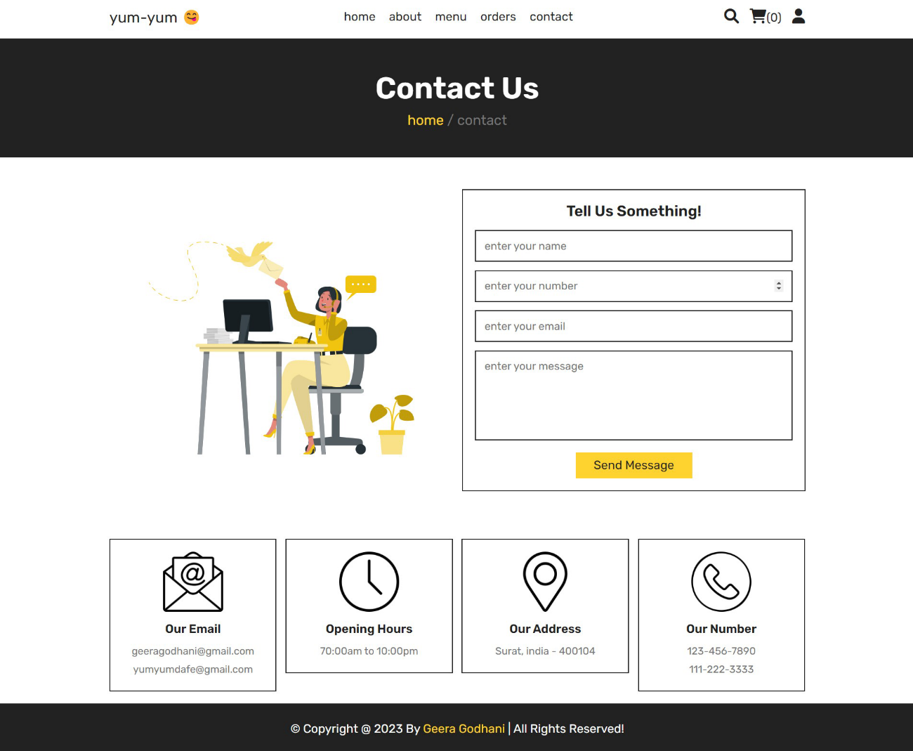

* **Admin Panel Home Page**

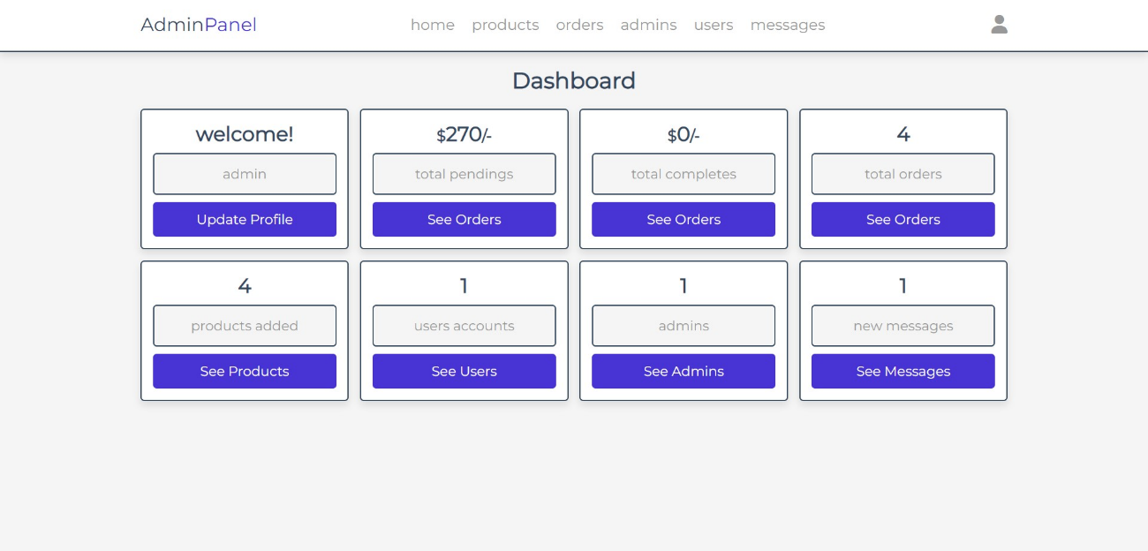

* **Add Product Page**

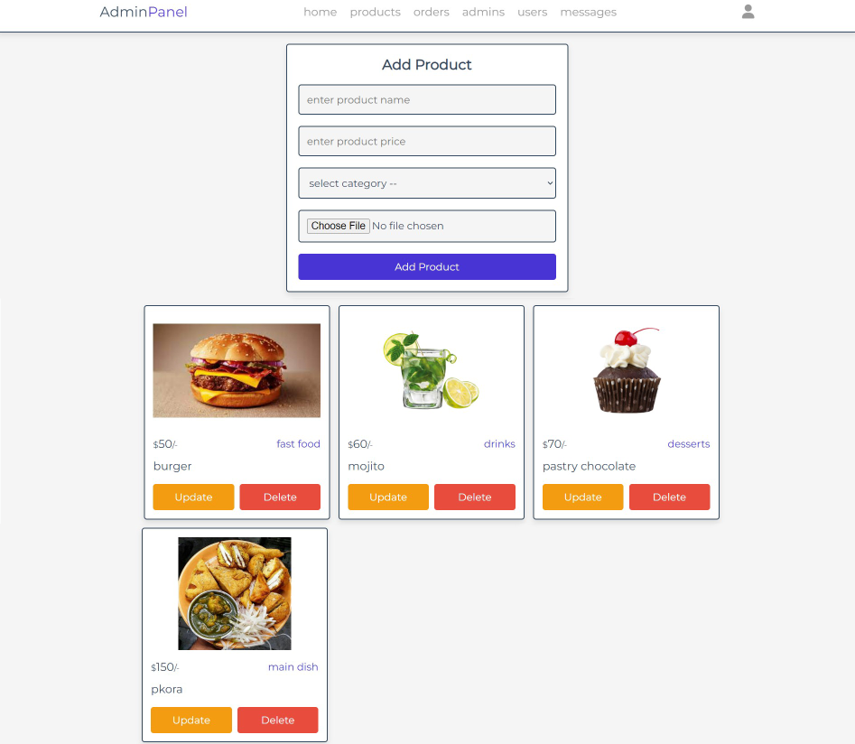

* **Placed Order Page**

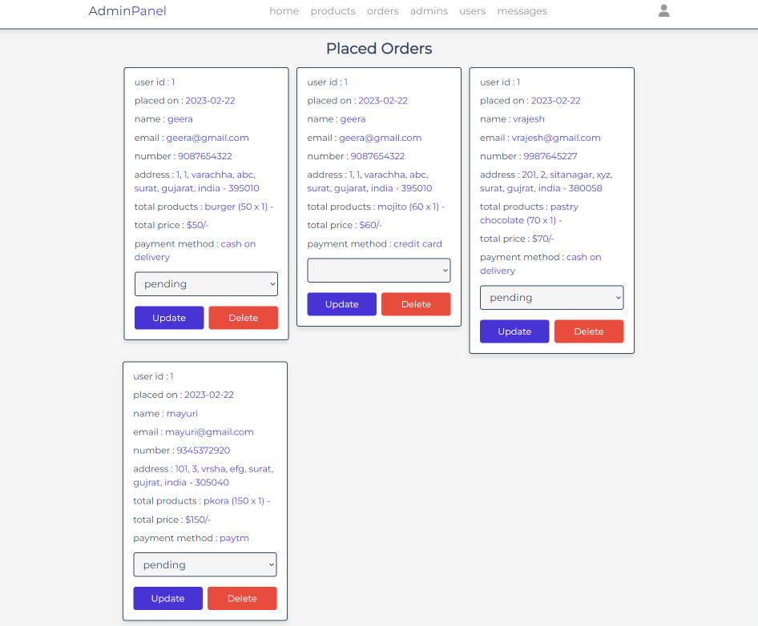

* **Admin Account Page**

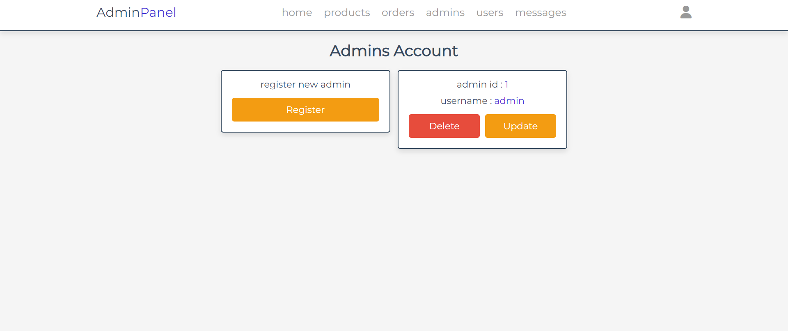

* **Users Account Page**

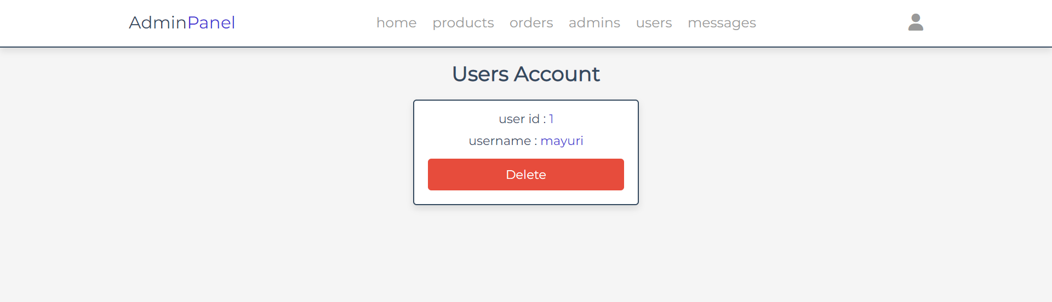

* **Messages Review Page**

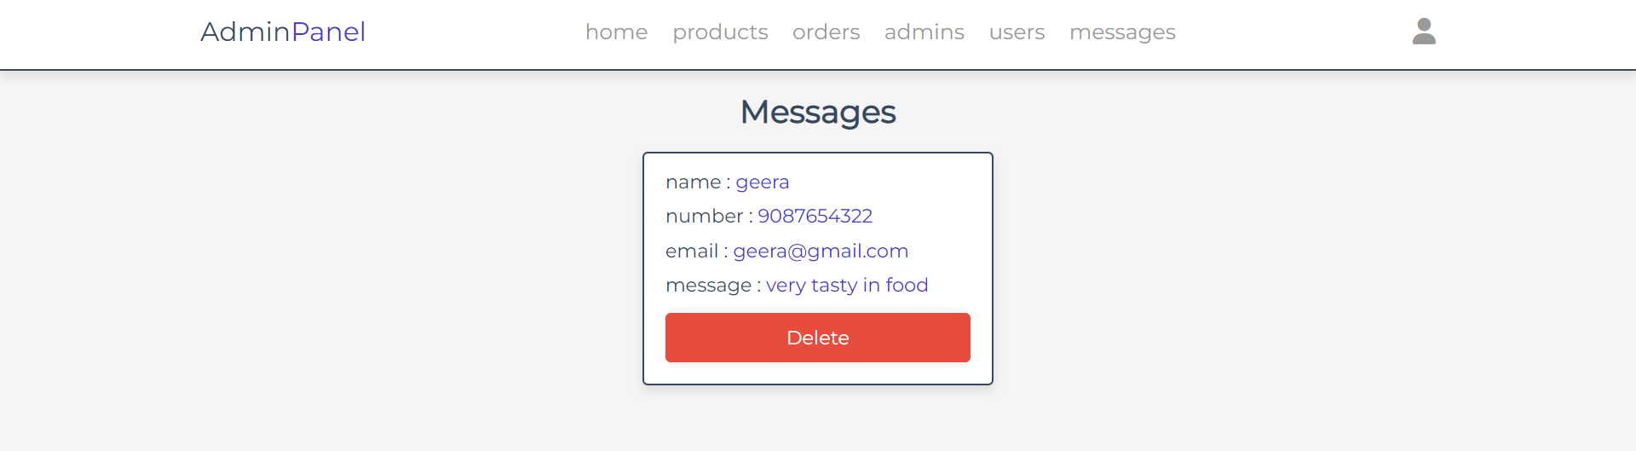

* **Update Profile Page**

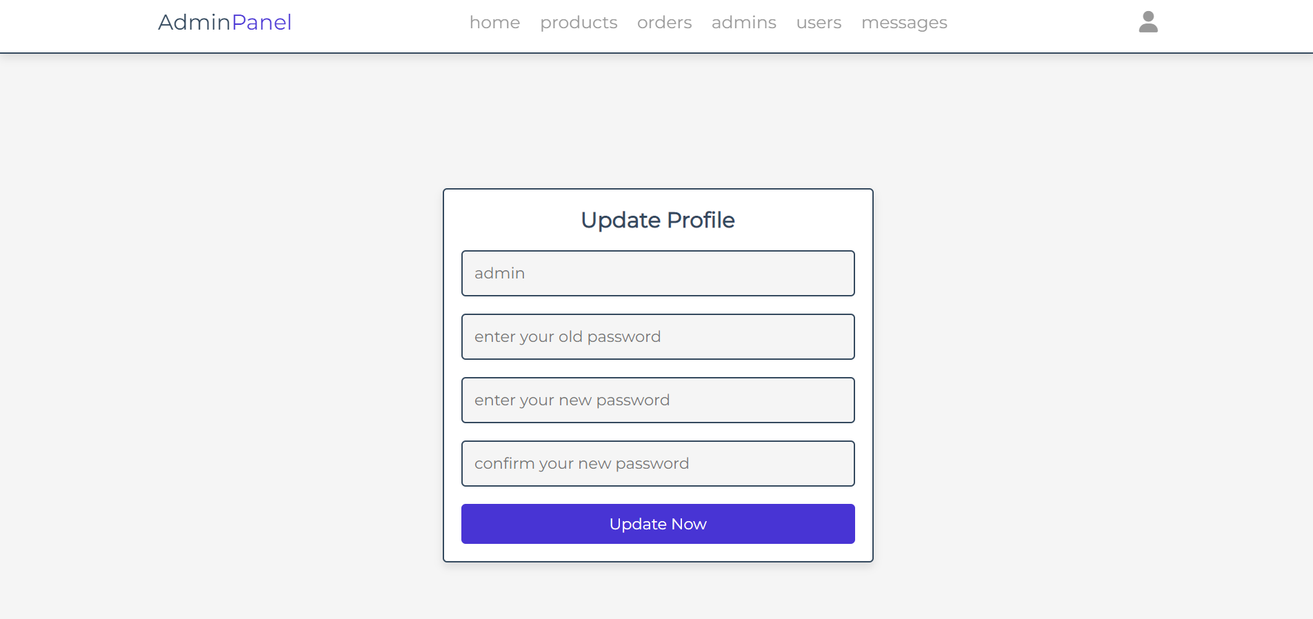

* **Register New Page**

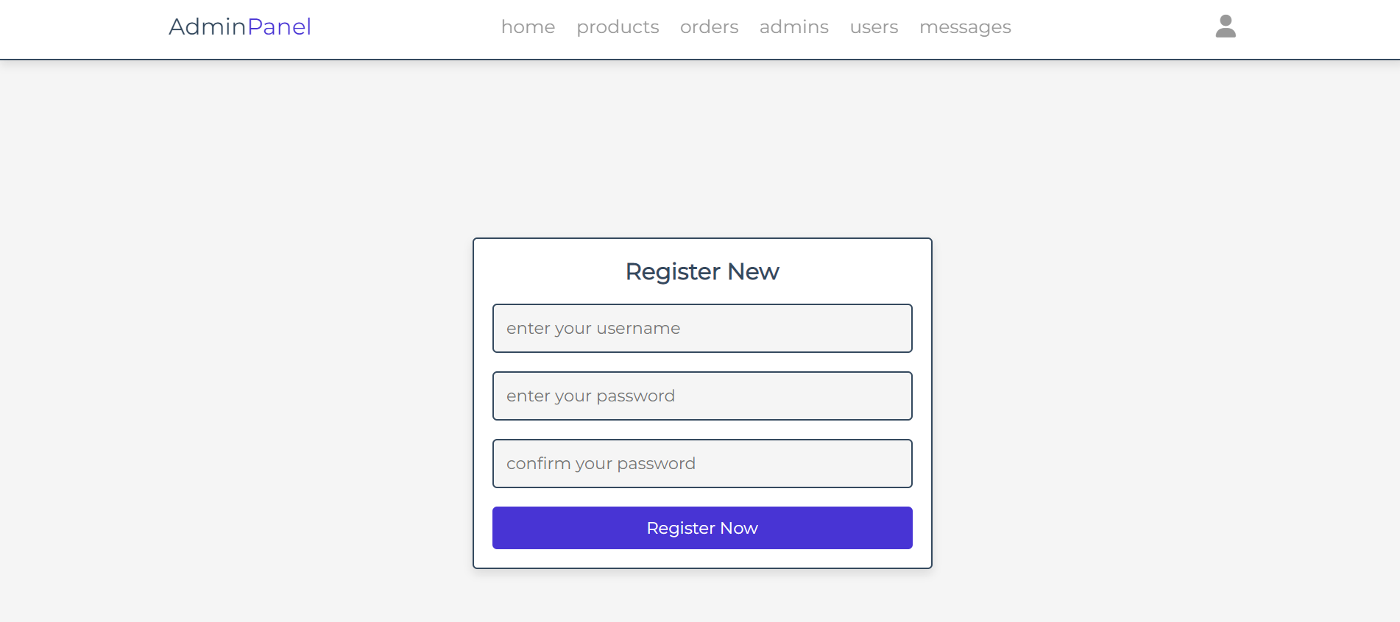

**9. Testing**

**9.1 Software Testing:**



Software testing is a critical element of software quality assurance and represents the ultimate review of specification design and coding testing an exposure of a system to trial input to see whether software meets correct output. Testing cannot be determining whether software meets user’s needs, only whether it appears to confirm to requirements. Testing can show that a system is free of errors, only that it contains error. Testing finds errors, it does not correct errors. Software success is a quality product, on time within cost. Through testing can reveal critical mistakes.

Testing should therefore,

* Validate Performance
* Detects Errors
* Identify Inconsistencies

**9.2 Unit Testing:**

The presented system is tested first using unit testing. Unit testing is test of code written by a single programmer. A unit is portion of system implemented by a single programmer. Unit testing is exercising a unit in isolation from the system. The system, them, is tested using integrating testing.

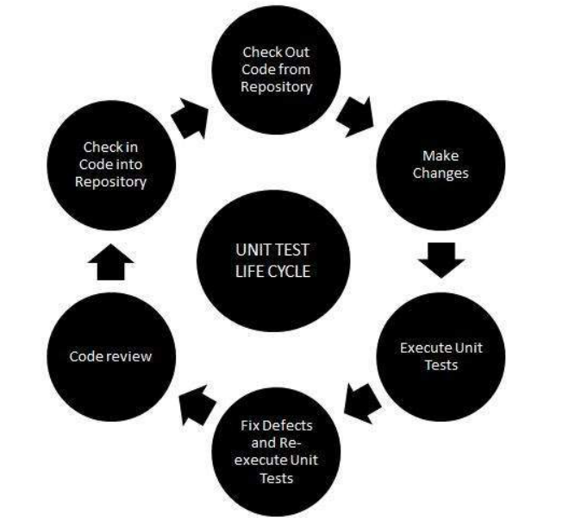

Unit testing can be performed from the bottom up, starting with smallest and lowest-level modules and proceeding one at time. For each module in bottom-up testing a short program is used to execute the module and provides the needed data. So that the module is asked to perform the way embedded within the large system.

**9.3 System Testing:**

This is performed after the system is put together. The system is tested against the system requirement are met and if the system performs of specify by the requirements.

Testing is an important function to the success of the system. System testing makes a logical assumption that if all parts of the system are correct. The goal will be successfully activated. Another reason for system testing is its utility as a user oriented vehicle before implementation.

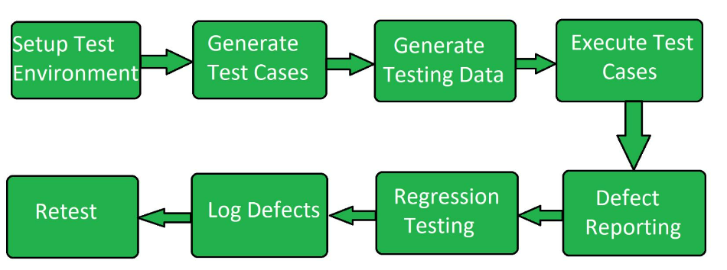

**System Testing Consists of Following Three Steps:**

1. **Programming Testing**

A program represents the logical elements of a system. For a program to run satisfactorily. It must compile and test data correctly and tie in properly with other programs. It is the responsibility to have an error free program. At the time of testing the system, there exist two types of errors that should be checked.

There errors are

* System Error
* Logic Error

A syntax error is a program statement that violates one or more rules of the language in which it is written. An improperly defined field dimension or omitted key words are common syntax errors. These errors are through error message generated by the computer.

A logic error, on the other hand with incorrect data fields out of range items, and invalid combinations. Since the logical errors are not detected by compile, the programmer must examine the output carefully to detect them.

When program is tested, the actual output is compared with the expected output. When there is a discrepancy, the sequence of the instructions, must be traced to determine the problem. Breaking the program down into self-contained portion, each of which can be checked at certain key points, facilitates the process.

1. **String Testing**

Programs are invariably related to one another and interact in total system. Each program is tested to see whether it confirms to related programs in the system. Each part of the system is tested against the entire module with both test and live data before the whole system is ready to be tested.

1. **System Testing**

System testing is designed to uncover weakness that was not found in earlier tests. This includes forced system failure and validation of total system. As its user in the operational environment will implement it. Under this testing, generally we take low volumes of transactions based on live data. This volume is increased until the maximum level for each transaction type is related. The total system is also tested for recovery and fall back after various major failures to ensure that no data are lost during the emergency.

**10. Reference**



* <https://www.stackoverflow.com/>
* <https://www.tutorialsoints.com/>
* <https://books.google.con.in/books/about/Learning_UML_2_0.hml>
* <https://www.github.com/>
* <https://www.w3schools.com/>
* <https://www.app.diagrams.net>
* <https://laravel.com/>
* <https://www.paradisosolutions.com/>
* <https://claned.com>